**Part 2: Data Entities, Attributes, and Files**

**GitHub Link:**

1. **Short Description of Entities:**

Five entities have been identified in the database system and these are mentioned along with its description below:

*i) Order:* Order is a vital entity of our E-commerce website that helps a customer to track their ordered items while shipment from warehouse to destination location.

*ii) Store:* Store entity of an E-commerce site is just like a physical store where a customer can get different options of a product and buy it.

*iii) Supplier:* Supplier is another essential entity which helps a customer to get contact with the delivery person and know about the current status of the supplier.

*iv) Customer:* Customer entity conveys an end-user about the section where one can perform all the consumer-oriented activities.

*v) Payment***:** It is the most essential entity that ensures the business transaction for the business and facilitates multiple options of payment to a customer.

2. Create 5 simple tables describing your entities, their attributes, and the data type of each attribute. For example:

| **Product Info** |  |
| --- | --- |
| Product Detail | varChar[20] |
| Quantity | Integer |
| Cost | Float |

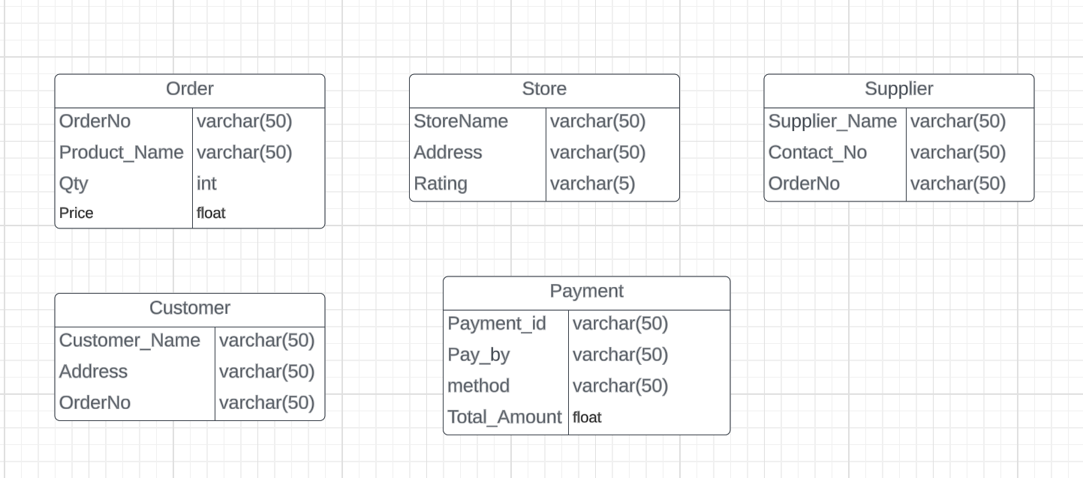

**Description of entities, attributes and Data Type of Each Attribute**

The tables created in the database consist of entities called Order, Store, Supplier, Customer and Payment. These entities are associated with each other as each entity plays a crucial role from the selection of product to the receiving of product.

Different phases of this E-commerce service starts from Customer where an individual registers in the portal with one’s name and address. Therefore, ‘Customer_Name’ and ‘Address’ are added to the entity ‘Customer’. In addition, with a successful buy of product will generate an order number for business owners making the ‘OrderNo’ essential to be added to ‘Customer’ entity. Likewise, the details of the Store are required such as its name, address and review. Subsequently, a ‘Store’ entity consists of ‘StoreName’, ‘Address’ and ‘Rating. In the third and fourth stage of business, order status and supplier emerges respectively. The ‘Order’ entity consists of ‘OrderNo’, ‘Product_Name’, ‘Qty’ and ‘Price’ and the entity ‘Supplier’ consists of ‘Supplier_Name’, ‘Contact_No’ and ‘OrderNo’. Similarly, the entity ‘Payment’ needs options, method and Total Amount for the product and alike attributes have been conducted in this entity.

The data type of most of the attributes of all the entities is Variable character (varchar). Apart from Varchar, the attributes ‘Qty’ and ‘Price’ have integer and float as data types respectively.

3. Create .CSV files for your entities and attributes. Each entity should have its own file. That means you will end up with 5 CSV files. Each file should also have 3 records that are specific examples of that entity. Save these files to your github.

4. Repeat step 3, but format the files in XML. That means you will have 5 files with 3 records each that populate at least 3 attributes per record using XML tags. You can define the tags any way you choose, but you must use the XML style. Save these files to your github.